**Domain Winter Camp DAY-5**

**Name = Priti**

**Section/Group:-901-Kpit-B**

**UID = 22BCS12729**

# Problem 1

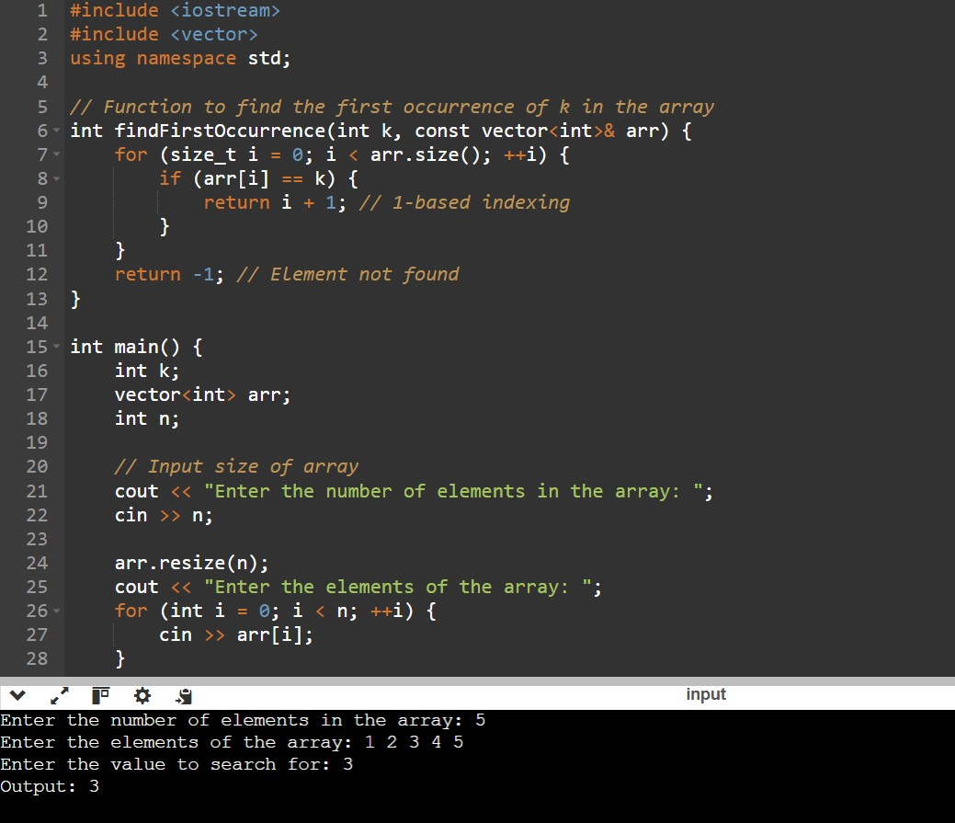

# Problem 2

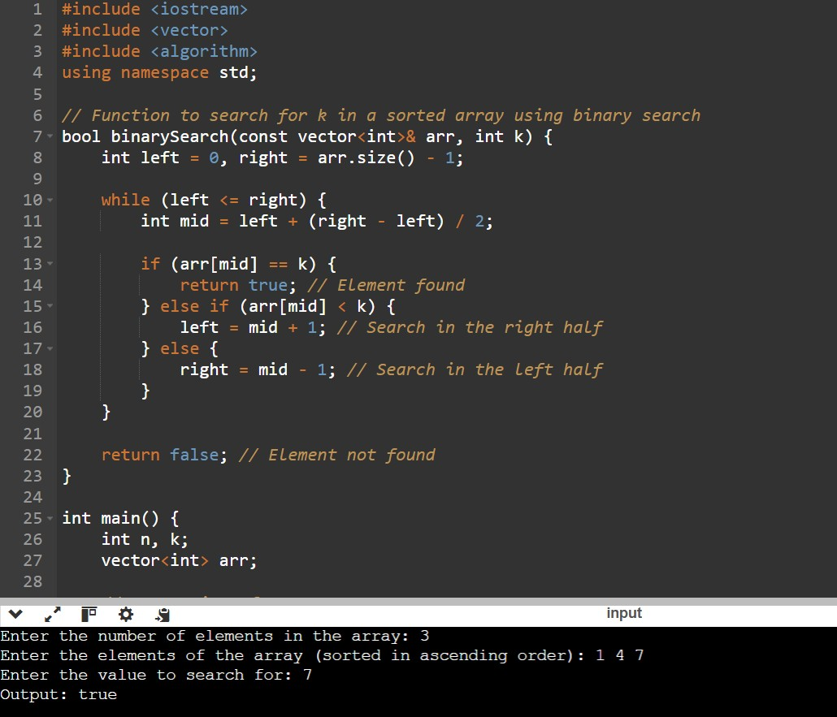

# Problem 3

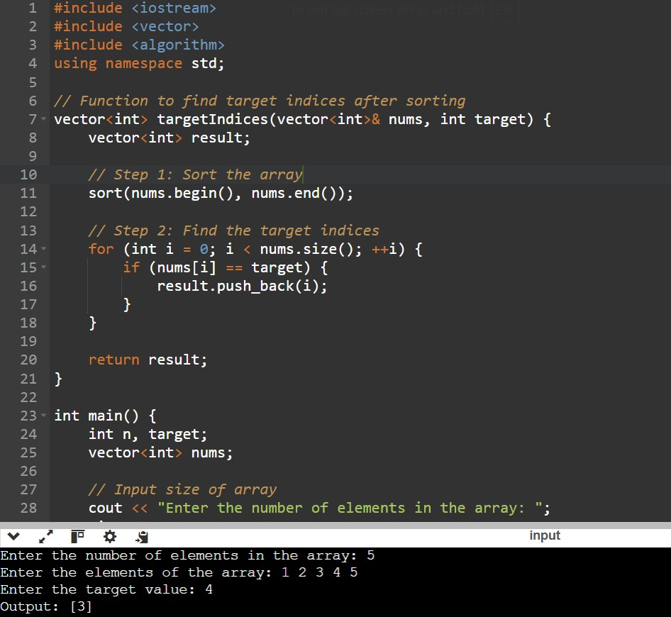

# Problem 4

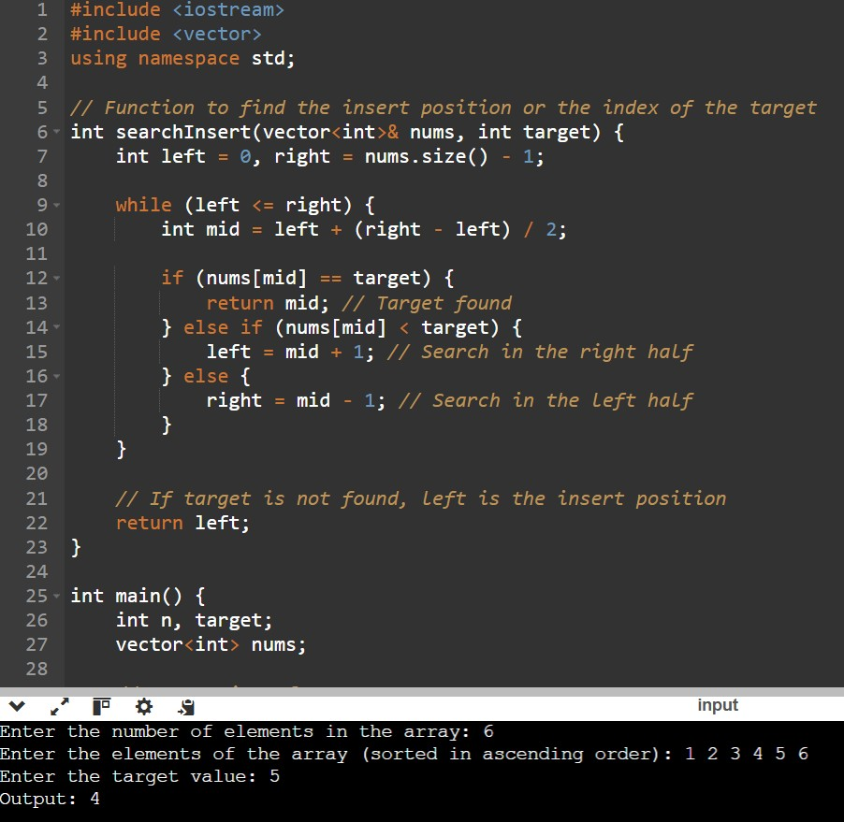

# Problem 5

